December monthly report
……..........................................................
Dr. Pongkarn Chakthranont
โครงการ P2451496 งบยุทธ_CCU68_การต่อยอดและพัฒนาเทคโนโลยี Carbon capture and utilization (CCU) ที่มีความต้องการจากภาคอุตสาหกรรม และขับเคลื่อน National CCUS Alliance ร่วมกับเครือข่ายพันธมิตร
Sothearoth Heng
Under the supervision of
Dr. Pongkarn Chakthranont
ใบสั่งจ้างเลขที่ PO25005060
จ้างเหมาพัฒนางานจ้างพัฒนาการขยายขนาดเซลล์ไฟฟ้าเพื่อการผลิตแก๊สสังเคราะห์จาก CO₂ เชิงเคมีไฟฟ้า
งวดที่ 8: 1 December 2568 – 31 December 2568

- To-do list in December
  - 100cm² MEA electrolyzer – CO₂ electrolysis of Sputtered Ag (500nm) in BPM system with 350µm/250µm silicone gaskets and 35 ft.lbs under a humidified 200ml/min CO₂, 100ml/min of 0.25M KOH, and IrO₂-TiPt anode at 100mA/cm²
  - Studies on hot-pressing 5cm² and 100cm² MEA optimization
  - 100cm² hot-pressed MEA electrolyzer – CO₂ electrolysis of 0.5Ni-SAC in BPM system with 350µm/250µm silicone gaskets and 35 ft.lbs under a humidified 200ml/min CO₂, 100ml/min of 0.25M KOH, and IrO₂-TiPt anode at 100mA/cm²
- Experimental Procedure
Synthesis of NiSAC by pyrolysis method
The synthesis of NiSAC catalyst was followed by our previous work. Initially, nickel phthalocyanine (NiPc), urea, and dicyanamide precursors were stoichiometrically weighed according to mass ratios of x:5:5, wherein urea and dicyanamide were maintained at 5 g each while varying the NiPc content (x = 0.25, 0.5, 1.0, and 2.0 g). Subsequently, the mixture was thoroughly mixed and ground until a homogeneous midnight blue powder was obtained. The fine powder was then transferred into a quartz boat covered with a capsule lid and subjected to polymerization at 800 °C (ramp rate = 10 °C·min⁻¹) in a horizontal tube furnace under an argon atmosphere (flow rate = 200 sccm) for 2 h. The as-prepared xNiSAC catalysts with different NiPc contents were finally obtained and labeled as 0.25NiSAC, 0.5NiSAC, 1.0NiSAC, and 2.0NiSAC.

Fabrication of IrO₂/TiPt felt anode electrode
The IrO₂/TiPt-felt anode electrode was prepared using a thermal deposition method involving multiple sequential steps. Initially, the TiPt felt (Purchased from ...) substrate was ultrasonically cleaned with deionized water and acetone to remove any surface contaminants. The cleaned substrate was subsequently etched in a 6M HCl solution at 90°C for 45 min to enhance surface roughness and adhesion properties. The dip-coating solution was prepared by dissolving 200 mg of IrCl₆·xH₂O in 18 mL of isopropanol (IPA) containing 10% v/v HCl (2 mL of conc. HCl). The etched TiPt felt substrate was then immersed in the dip-coating solution, followed by drying at 100°C for 5 min in an oven and subsequent calcination at 500°C for 10 min in a muffle furnace. After cooling to room temperature, the treated substrate was reweighed to determine mass gain. This dipping-drying-calcination cycle was repeated several times until the desired IrO₂ mass loading (1±0.2 mg/cm²) was achieved.

Preparation of NiSAC cathode electrode via spray coating method
The NiSAC gas-diffusion electrode was fabricated by spray coating onto Sigracet 39BB carbon paper or hydrophilic carbon cloth substrates. Typically, 150 mg of as-prepared NiSAC and 381 μL of XC-2 ionomer were ultrasonically dispersed in 10 mL of isopropanol (IPA) for at least 1 h to form a homogeneous dark colloidal suspension. The ink suspension was subsequently spray-coated onto a 11 x 11 cm² carbon substrate using an automated, custom-built spraying setup equipped with a syringe pump operating at a flow rate of 0.6 mL min⁻¹ on a hotplate maintained at 130°C, yielding a catalyst mass loading of 1.8 ± 0.1 mg.cm⁻².
Note: a bottle of ink suspension containing 150mg of Ni-SAC catalyst yields only ~ 0.7 ± 0.1 mg.cm⁻².

Electrochemical measurements in membrane-electrode assembly (MEA) electrolyzer
100cm2 MEA electrolyzer operational set-up
A 100 cm² MEA electrolyzer was used to evaluate the CO2RR performance under modulated operating conditions. The Ni foam or IrO₂-TiPt felt (10.5 x 10.5 cm²), bipolar membrane (BPM, 15.6 x 16.8 cm²), and 0.5Ni-SAC (10.5 x 10.5 cm²) were employed as the anode, membrane, and cathode electrode, respectively. The MEA was assembled with 0.25µm PTFE gasket and tightened at a compression force of 35 ft.lb. 1.0 L of 0.25 M KOH was recirculated and used throughout the experiment as the anolyte at 100 ml/min. The humidified CO₂ gas stream was introduced into the cathodic inlet with a total CO₂ flow rate of 200-1000 ml/min. Prior the test, the electrochemical impedance spectroscopy (EIS) and Cyclic voltammetry were measured. Meanwhile, the cathodic outlet was directly injected into an online gas-chromatography for gas products analysis.

- Results
Investigation of CO₂ electrolysis with different cathode materials in 100cm² MEA
To rigorously evaluate our hypothesis that the uniformity of the Ni-SAC catalyst layer on the GDE influences overall cell instability, CO₂ electrolysis was performed using a sputtered Ag catalyst (500 nm) under identical operating conditions. As shown in Figure 1, the cell exhibited predominantly hydrogen evolution reaction (HER) activity, with an average Faradaic efficiency for H₂ exceeding 80%, while maintaining an average cell potential of 3.55 V over 70 h of continuous operation. The apparent operational stability of this MEA is therefore primarily attributed to the dominant HER pathway, which stabilizes the cell potential over time. As a result, the observed stability does not directly reflect the influence of catalyst-layer uniformity, and these results cannot validate its role in governing long-term cell stability.
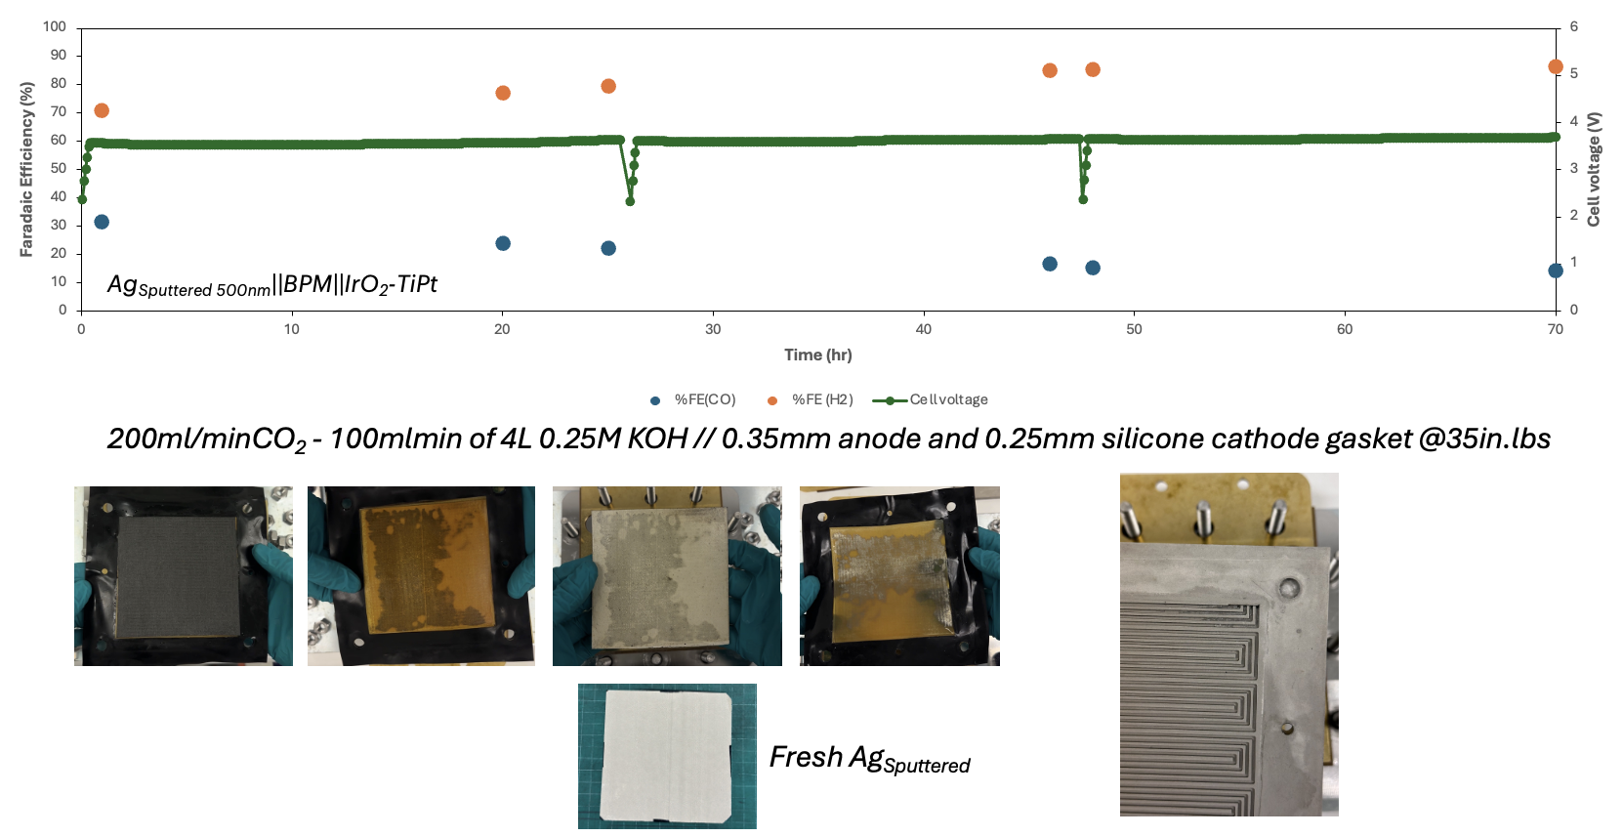
Figure 1. CO₂ electrolysis of sputtered Ag (500nm) cathode material under 200 ml/minCO₂, 100 ml/min of 4L 0.25M KOH // 0.35mm anode and 0.25mm silicone cathode gasket @35in.lbs in 100cm² MEA electrolyzer.

Studies on hot-pressing 5cm² and 100cm² MEA optimization
In addition to the effect of catalyst-layer uniformity, which may lead to poor interfacial contact between the electrode and the membrane, hot-pressing represents an alternative approach to further improve electrode–membrane contact through the application of heat and compressive force. To optimize the hot-pressing conditions, a 5 cm² MEA was initially used to establish parameters that could later be applied to a 100 cm² MEA. As shown in Figure 2, different compression pressures (20, 30, and 40 kg cm⁻²) were applied to the 5 cm² MEA at room temperature with a holding time of 5 min. A compression pressure of 30 kg cm⁻² was identified as the optimal condition, as it provided improved interfacial contact without causing damage to the GDE backside. When this optimized hot-pressing condition was applied to the larger 100 cm² MEA, poor electrode–membrane contact was still observed, despite the application of higher compressive force. To increase the effective pressure on the electrode, the additional 250 µm gasket layer was removed, and the electrode was hot-pressed under the same optimized conditions established for the 5 cm² MEA. Although full contact between the electrode and membrane was achieved, slight damage and partial delamination of the GDL backside from the GDE were observed. Despite multiple attempts to improve interfacial contact, the hot-pressed 100 cm² MEA was assembled into the electrolysis cell for CO₂ electrolysis performance testing. As shown in Figure 3, the hot-pressed 100 cm² MEA exhibited a cell-potential profile similar to that of the previous 100 cm² MEA system, with an initial cell potential of approximately 3.3 V, followed by overpotential overshoot after 5 h of operation.
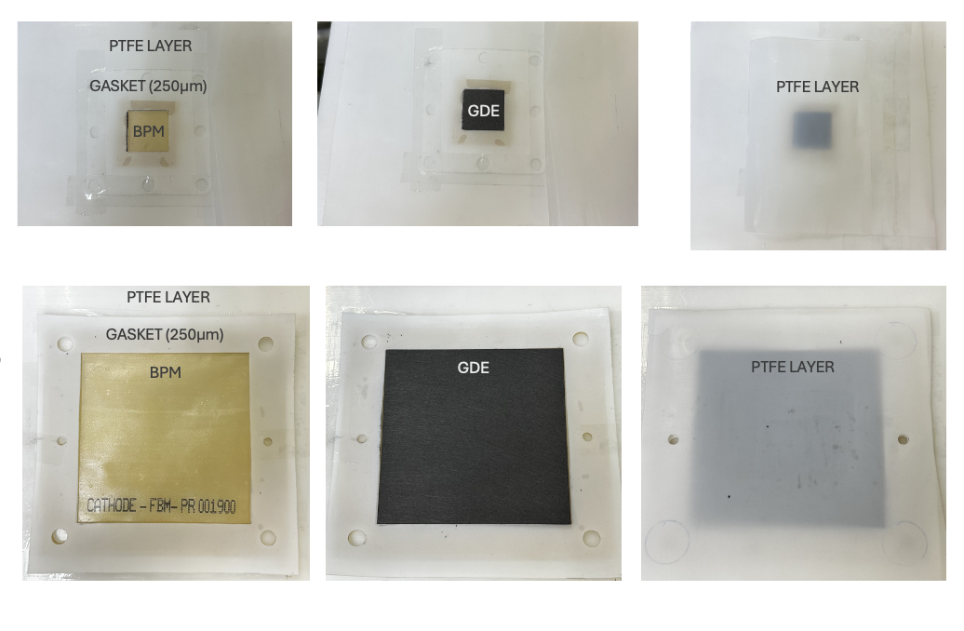
Figure 2. Step-by-step of hot-pressing process for 5 and 100 cm² MEA
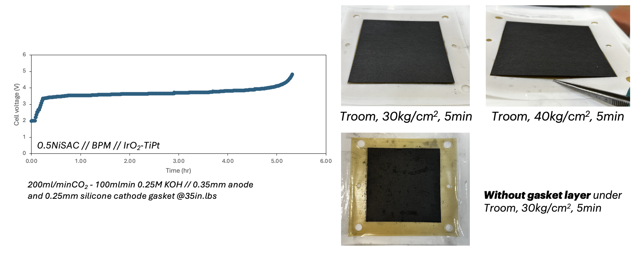
Figure 3. CO₂ electrolysis of 100cm² hot-pressed MEA electrolyzer with 350/250µm silicone gasket and compression force of 35 ft.lb under 200ml/min of CO₂, 100ml/min 0.25M KOH, and IrO₂-TiPt anode at 100mA/cm².

